Name : Sanika Sashte

Emp Id : 26210050

1. Write a shell script which will generate the O/P as follows

*

**

***

****

**Ans :**

**vim pattern1.sh**

**#!/bin/bash**

**# Number of rows**

**rows=4**

**# Loop to print the pattern**

**for ((i=1; i<=rows; i++)); do**

**for ((j=1; j<=i; j++)); do**

**echo -n "*"**

**done**

**echo "" # Move to the next line**

**done**

**chmod +x pattern.sh**

**./pattern1.sh**

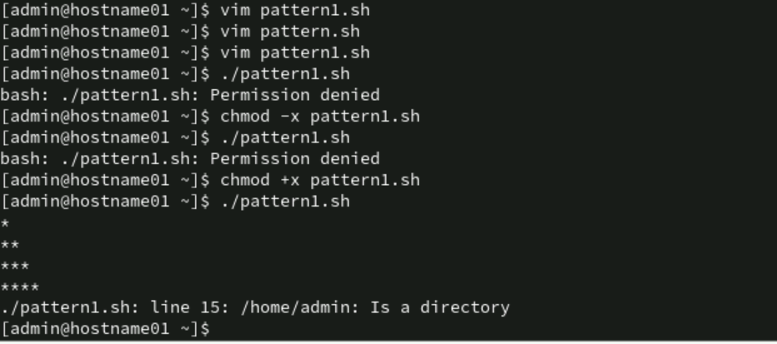

1. Accept the first name, middle name, and last name of a person in variables fname, mname and lname respectively. Greet the person (take his full name) using appropriate message.

**Ans.**

**vim Sanikagreet.sh**

**#!/bin/bash**

**# Accept first name, middle name, and last name**

**read -p "Enter First Name: " fname**

**read -p "Enter Middle Name: " mname**

**read -p "Enter Last Name: " lname**

**# Display Greeting Message**

**echo "Hello, $fname $mname $lname! Welcome to Shell Scripting."**

**chmod +x Sanikagreet.sh**

**./Sanikagreet.sh**

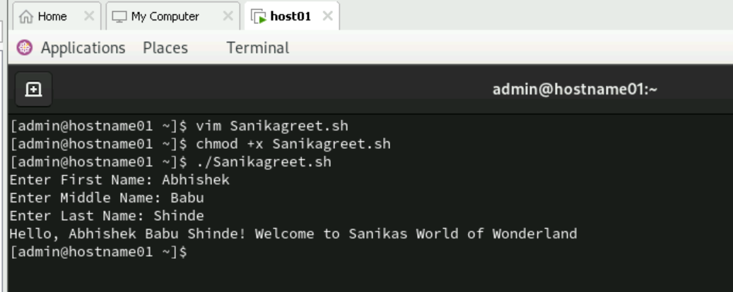

1. Display the name of files in the current directory along with the names of files with maximum & minimum size. The file size is considered in bytes.

vim filesize.sh

#!/bin/bash

# Display all files with their sizes

echo "Files in the Current Directory:"

ls -lS --block-size=1 | awk '{print $5, $9}' | tail -n +2

# Get the smallest and largest files

max_file=$(ls -S | head -n 1)

min_file=$(ls -Sr | head -n 1)

# Get their sizes in bytes

max_size=$(stat -c%s "$max_file")

min_size=$(stat -c%s "$min_file")

# Display Results

echo -e "\n Largest File: $max_file ($max_size bytes)"

echo " Smallest File: $min_file ($min_size bytes)"

chmod +x file_sizes.sh

./filesize.sh

1. Write a script which when executed checks out whether it is a working day or not?

(Note: Working day Mon-Fri)

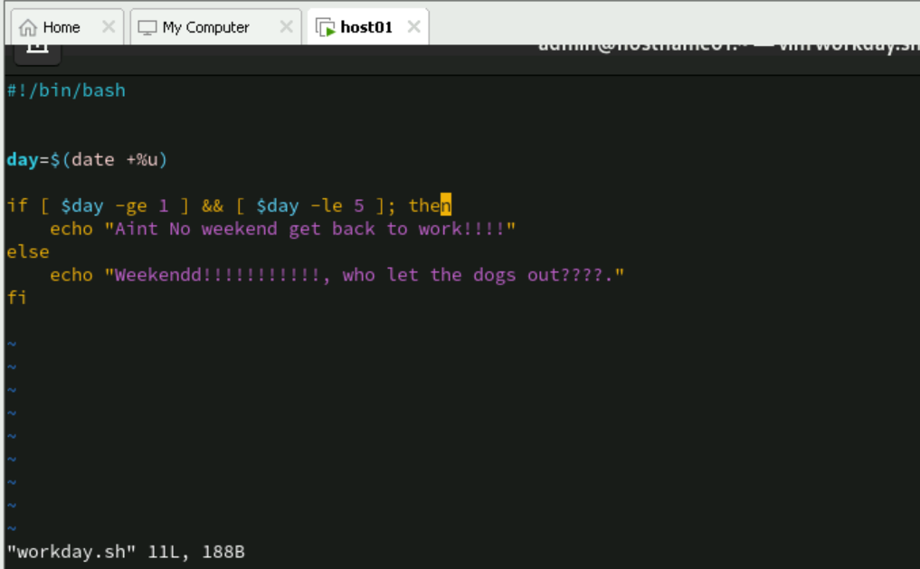

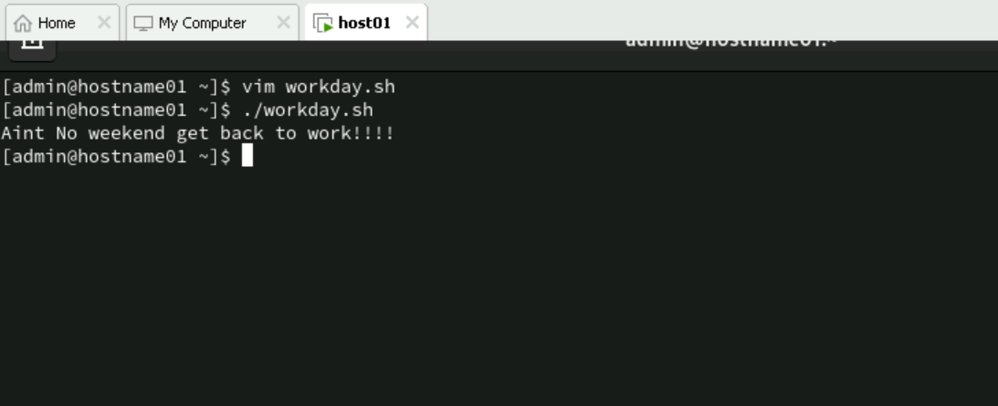

1. Write a script that accepts a member into HP health club, if the weight of the person is withing the range of 30-250 Kgs.

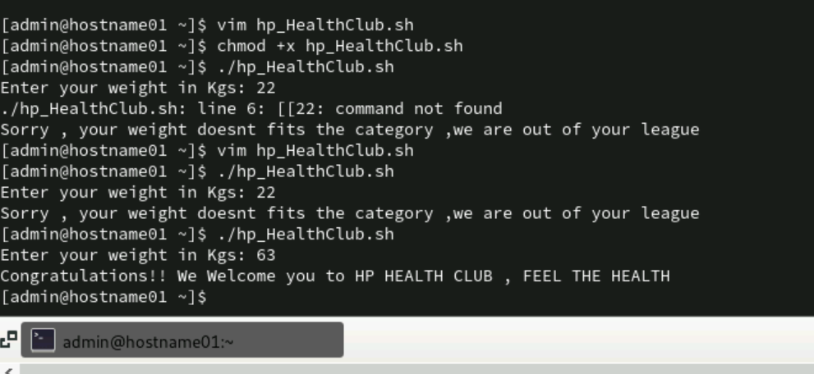

Ans

#!/bin/bash

echo -n "Enter your weight in Kgs: "

read weight

if [[ $weight -ge 30 && $weight -le 250 ]]; then

echo "Congratulations!! We Welcome you to HP HEALTH CLUB , FEEL THE HEALTH"

else

echo "Sorry , your weight doesnt fits the category ,we are out of your league"

fi

1. Write a shell script that greets the user with an appropriate message depending on the system time.

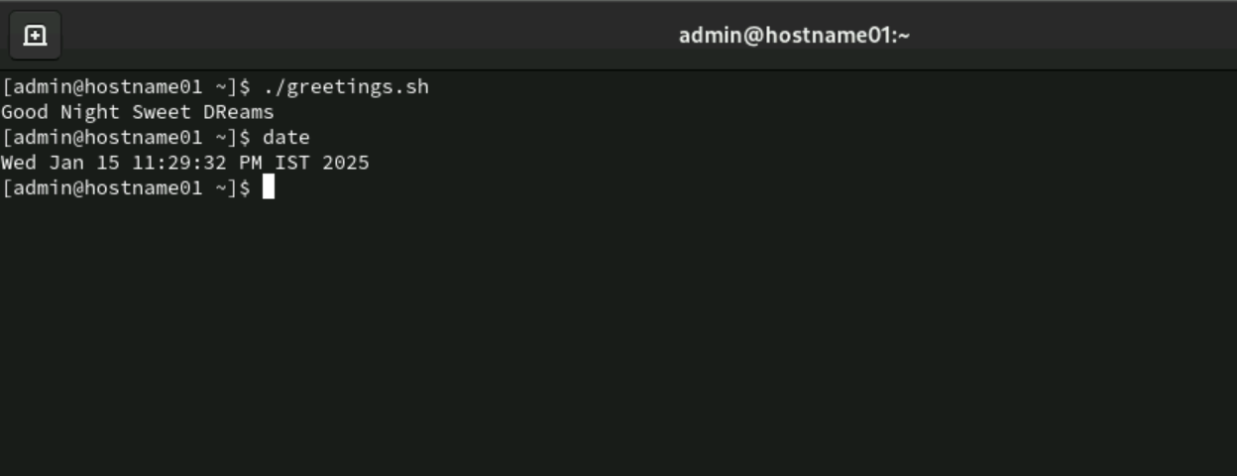

Ans

1. A data file file has some student records including rollno, names and subject marks. The fields are separated by a “:”. Write a shell script that accepts roll number from the user, searches it in the file and if the roll number is present - allows the user to modify name and marks in 3 subjects.   
   If the roll number is not present, display a message “Roll No Not Found”. Allow the user to modify one record at a time.

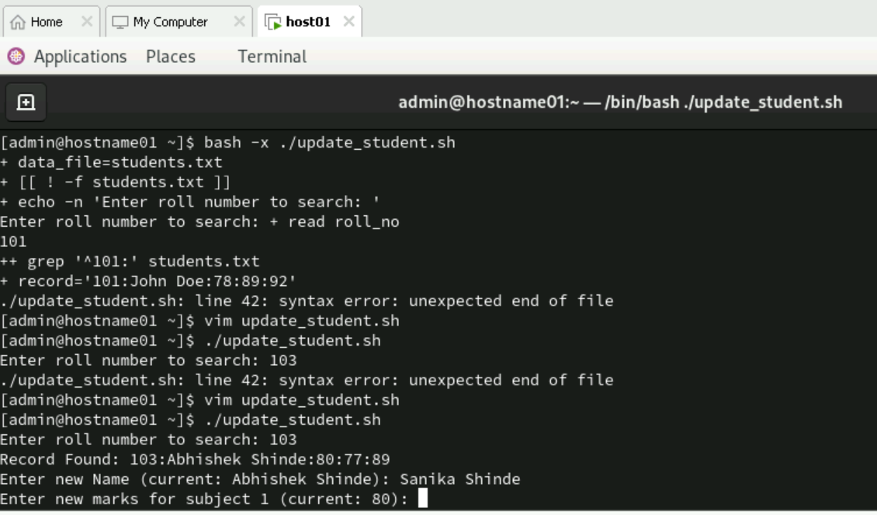

Code

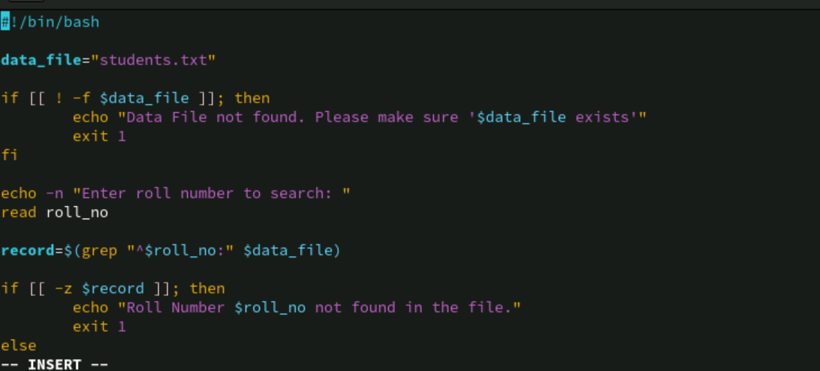

1. Modify program 7 to accept the RollNo from the command line.

Ans:

**vim update_student.sh**

**#!/bin/bash**

**# File containing student records**

**data_file="students.txt"**

**# Check if the roll number is provided as a command-line argument**

**if [ -z "$1" ]; then**

**echo "Usage: $0 <rollno>"**

**exit 1**

**fi**

**# Get the roll number from the command-line argument**

**rollno=$1**

**# Search for the roll number in the file using grep**

**record=$(grep "^$rollno:" "$data_file")**

**if [ -z "$record" ]; then**

**echo "Roll No Not Found"**

**else**

**# Display the current record**

**echo "Current record: $record"**

**# Prompt the user to enter the new name and marks**

**echo "Enter the new name:"**

**read new_name**

**echo "Enter the new marks for subject 1:"**

**read new_marks1**

**echo "Enter the new marks for subject 2:"**

**read new_marks2**

**echo "Enter the new marks for subject 3:"**

**read new_marks3**

**# Create the new record**

**new_record="$rollno:$new_name:$new_marks1:$new_marks2:$new_marks3"**

**# Replace the old record with the new record in the file using sed**

**sed -i "s/^$rollno:.*/$new_record/" "$data_file"**

**echo "Record updated successfully."**

**fi**

1. Modify the program 7 to accept the RollNo and display the record and ask for delete confirmation. Once confirmed delete the record and update the data file.

**Ans: 1.vim deletestudent.sh**

**#!/bin/bash**

**# File containing student records**

**data_file="students.txt"**

**# Check if the roll number is provided as a command-line argument**

**if [ -z "$1" ]; then**

**echo "Usage: $0 <rollno>"**

**exit 1**

**fi**

**# Get the roll number from the command-line argument**

**rollno=$1**

**# Search for the roll number in the file using grep**

**record=$(grep "^$rollno:" "$data_file")**

**if [ -z "$record" ]; then**

**echo "Roll No Not Found"**

**else**

**# Display the current record**

**echo "Current record: $record"**

**# Ask for delete confirmation**

**echo "Do you want to delete this record? (yes/no)"**

**read confirmation**

**if [ "$confirmation" = "yes" ]; then**

**# Delete the record from the file using sed**

**sed -i "/^$rollno:/d" "$data_file"**

**echo "Record deleted successfully."**

**else**

**echo "Deletion cancelled."**

**fi**

**fi**

**2.chmod +x deletestudent.sh**

**3. ./deletestudent.sh**

1. Write a script that takes a command line argument and reports on its file type (regular file, directory file, etc.). For more than one argument generate error message.

**1] vim type_of_file.sh**

**#!/bin/bash**

**# Check if more than one argument is provided**

**if [ "$#" -ne 1 ]; then**

**echo "Usage: $0 <filename>"**

**exit 1**

**fi**

**# Get the filename from the command-line argument**

**filename=$1**

**# Check if the file exists**

**if [ ! -e "$filename" ]; then**

**echo "File does not exist."**

**exit 1**

**fi**

**# Determine the file type**

**if [ -f "$filename" ]; then**

**echo "$filename is a regular file."**

**elif [ -d "$filename" ]; then**

**echo "$filename is a directory."**

**elif [ -L "$filename" ]; then**

**echo "$filename is a symbolic link."**

**else**

**echo "$filename is of another file type."**

**fi**

**2] chmod +x type_of_file.sh**

**3] ./type_of_file.sh <filename>**

1. Add some student records in the “student” file manually. The fields to be considered are “RollNo”, “Name”, “Marks_Hindi”, “Marks_Maths”, “Marks_Physics”.  
    Write a script which does the following
   1. If the roll number already exists, then store the record and the following message   
      “roll number exists” in a log file “log1”.
   2. If the marks in the subjects is not in the range of 1 – 99 then store such a record followed by a message “marks out of range” in “log1”
   3. If the data is valid, the calculate total, percentage, grade and display on the terminal

**vim studentrecords.sh**

**#!/bin/bash**

**# File containing student records**

**data_file="student"**

**log_file="log1"**

**# Function to calculate grade based on percentage**

**calculate_grade() {**

**local percentage=$1**

**if (( $(echo "$percentage >= 90" | bc -l) )); then**

**echo "A"**

**elif (( $(echo "$percentage >= 80" | bc -l) )); then**

**echo "B"**

**elif (( $(echo "$percentage >= 70" | bc -l) )); then**

**echo "C"**

**elif (( $(echo "$percentage >= 60" | bc -l) )); then**

**echo "D"**

**else**

**echo "F"**

**fi**

**}**

**# Prompt the user to enter student details**

**echo "Enter Roll Number:"**

**read rollno**

**echo "Enter Name:"**

**read name**

**echo "Enter Marks in Hindi:"**

**read marks_hindi**

**echo "Enter Marks in Maths:"**

**read marks_maths**

**echo "Enter Marks in Physics:"**

**read marks_physics**

**# Check if the roll number already exists**

**if grep -q "^$rollno:" "$data_file"; then**

**echo "$rollno:$name:$marks_hindi:$marks_maths:$marks_physics" >> "$log_file"**

**echo "roll number exists" >> "$log_file"**

**echo "Roll number exists. Logged in $log_file."**

**exit 1**

**fi**

**# Check if the marks are in the valid range**

**if [ "$marks_hindi" -lt 1 ] || [ "$marks_hindi" -gt 99 ] || [ "$marks_maths" -lt 1 ] || [ "$marks_maths" -gt 99 ] || [ "$marks_physics" -lt 1 ] || [ "$marks_physics" -gt 99 ]; then**

**echo "$rollno:$name:$marks_hindi:$marks_maths:$marks_physics" >> "$log_file"**

**echo "marks out of range" >> "$log_file"**

**echo "Marks out of range. Logged in $log_file."**

**exit 1**

**fi**

**# Calculate total, percentage, and grade**

**total=$((marks_hindi + marks_maths + marks_physics))**

**percentage=$(echo "scale=2; $total / 3" | bc)**

**grade=$(calculate_grade "$percentage")**

**# Display the results**

**echo "Total Marks: $total"**

**echo "Percentage: $percentage%"**

**echo "Grade: $grade"**

**# Append the valid record to the data file**

**echo "$rollno:$name:$marks_hindi:$marks_maths:$marks_physics:$total:$percentage:$grade" >> "$data_file"**

**2] chmod +x studentrecords.sh**

**3] ./studentrecords.sh**